Software Requirements Specification
for
Multipath Routing Based On Fuel Efficiency and Emergency Service
Version 1.0 approved
Prepared by
Rutuja Raut
Vishakha Umale
Onkar Sarkate
Rohit Pawar

Vishwakarma Institute of Information Technology
Table of Contents
Table of Contents ii
Revision History ii
1. Introduction 1
1.1 Purpose 1
1.2 Document Conventions 1
1.3 Intended Audience and Reading Suggestions 1
1.4 Product Scope 1
1.5 References 1
2. Overall Description 2
2.1 Product Perspective 2
2.2 Product Functions 2
2.3 User Classes and Characteristics 2
2.4 Operating Environment 2
2.5 Design and Implementation Constraints 2
2.6 User Documentation 2
2.7 Assumptions and Dependencies 3
3. External Interface Requirements 3
3.1 User Interfaces 3
3.2 Hardware Interfaces 3
3.3 Software Interfaces 3
3.4 Communications Interfaces 3
4. System Features 4
4.1 System Feature 1 4
4.2 System Feature 2 (and so on) 4
5. Other Nonfunctional Requirements 4
5.1 Performance Requirements 4
5.2 Safety Requirements 5
5.3 Security Requirements 5
5.4 Software Quality Attributes 5
5.5 Business Rules 5
6. Other Requirements 5
Appendix A: Glossary 5
Appendix B: Analysis Models 5
Appendix C: To Be Determined List 6

Revision History
Name | Date | Reason For Changes | Version

Introduction

Purpose
Various emergency handling services are present worldwide to cater to the emergencies faced by the common man. The USA has its own such system by the name .At present, India does not have a such similar well defined emergency-handling approach. EMS is developed keeping in mind the lack of any such system in India. It is loosely based on system, but suited more to india.EMS is responsible for leading the department in providing a properly planned and organized emergency management force, capable of responding to public emergencies.

The person in an emergency or anybody at the emergency site will call EMS at avail the service. The common man can make use of this system in case of any emergencies. The system works is such a way, that victims will receive help in the form of police, fire, ambulances or fire-brigades depending on the situation. This system drives to and responds to emergencies promptly.

As population increases so does the importance of emergency services. The need of emergency services is increasing day by day. One such service is ambulance. Today there are a hundred ambulance services running yet unknown to people. Every hospital has its own contact number for the ambulance. Ever private and government Service has its own contact number for ambulance. It becomes really hectic for a person to call all these numbers and ask for an ambulance.

Document Conventions
This SRS is as per the IEEE conventions. The document follows Times New Roman Font with a font size of 12. All the headings have been made bold and are of font size 14.

<Describe any standards or typographical conventions that were followed when writing this SRS, such as fonts or highlighting that have special significance. For example, state whether priorities for higher-level requirements are assumed to be inherited by detailed requirements, or whether every requirement statement is to have its own priority.>

Intended Audience and Reading Suggestions
The document is intended to be read by the developers, users, testers, project manager and the documentation writers. The rest of the SRS describes briefly about the implementation of the chatbot system. It provides a broader view of the scope, objectives and the goals to be achieved. The SRS provides the overall description of the system considering different modules. Following which are the system requirements, features and the constraints. This also deals with the safety, security and quality attributes of the system.

<Describe the different types of reader that the document is intended for, such as developers, project managers, marketing staff, users, testers, and documentation writers. Describe what the rest of this SRS contains and how it is organized. Suggest a sequence for reading the document, beginning with the overview sections and proceeding through the sections that are most pertinent to each reader type.>

Product Scope
Currently this application is working only on android. But if the response is good this can be developed for all possible platforms.

The user would be able to track his requested ambulance. He would be able to know the exact location of the ambulance as the ambulance knows his.

As the accuracy of the geo-location increases, the more accurate position of the patient can be obtained.

In future a priority can be added according to the emergency occurred or the need of the ambulance.

Multiple requests from one position can be eliminated by setting a no request zone around any user who requested.

<Provide a short description of the software being specified and its purpose, including relevant benefits, objectives, and goals. Relate the software to corporate goals or business strategies. If a separate vision and scope document is available, refer to it rather than duplicating its contents here.>

References
- https://en.wikipedia.org/wiki/Himmat_(app).
- Osnat (Ossi) Mokryn Dror Karmi Akiva Elkayam Tomer Teller\Help Me: Opportunistic Smart Rescue Application and System"," 2012 The 11th Annual Mediterranean Ad Hoc Networking Workshop (Med-Hoc-Net).
- International Journal of Science and Research (IJSR), India Online ISSN: 2319-7064 ,Volume 2 Issue 9, September 2013, www.ijsr.net ,’Vehicle Tracking System Using GPS’ Sathe Pooja, Disha Institute of Management & Technology, Raipur, Chhattisgarh, India
- Ghaith Bader Al-Suwaidi, Mohamed Jamal Zemerly, “Locating friends and family using mobile phones with global positioning system(GPS),” IEEE/ACS International conference on Computer Systems and Applications, 2009
- Nadesh, R.K., Jayashree, K.Nirupama, lVijayashree, K.Anish Fatima (2011): "Mobile Tracking Application for Locating Friends using LBS ". International Journal of Engineering Science and Technology (IJEST).
- J. Scott, P. Hui, J. Crowcroft, and C. Diot, “Haggle: A networking architecture designed around mobile users,” IFIP WONS, vol. 2006.

<List any other documents or Web addresses to which this SRS refers. These may include user interface style guides, contracts, standards, system requirements specifications, use case documents, or a vision and scope document. Provide enough information so that the reader could access a copy of each reference, including title, author, version number, date, and source or location.>

Overall Description

Product Perspective
Typically the work done by geo-location sensors is: They report your location to other user, and they associate real-world location to your location. You get a richer experience of geo-location sensor when used with mobile devices than desktops because the relevant data you send and receive changes as your location changes. There is a GPS chip inside in every smartphone, which uses the satellite data to get its exact location which services such as Google maps can map. When GPS signal is not available, then the smartphone use the cell tower information to triangulate your location. The accuracy of this location is lower than GPS, but it has greatly improved in recent years. Some geo-location systems use GPS and cell site triangulation (and in some instances, local Wi-Fi networks) in combination to zero in on the location of a device.

In relative positioning, difference between GPS measurements taken by two receivers, is formed to remove or considerably reduce the effect of errors which are common to the measurements, atmospheric being the major one. Hence if the location of reference receiver is known then the absolute position can be computed. In relative positioning, the rover position is determined with respect to a known point usually called a reference, base or master station.

The code or phase range can be used to find the relative position of the rover. Phase range are much more accurate the code measurements. Although they have an additional unknown called integer ambiguity which needs to be solved before we can obtain the accurate position is determined.
To calculate the distance to the satellite, the amount of delay caused by receiver can be used. Simple triangulation determines the position on the Earth surface. This takes a look at the time of course because the GPS system you have in your hand or in your car is not going to have a strengthen signal one clock, which is a type of clock provided by the satellite. So synchronization is necessary

<Describe the context and origin of the product being specified in this SRS. For example, state whether this product is a follow-on member of a product family, a replacement for certain existing systems, or a new, self-contained product. If the SRS defines a component of a larger system, relate the requirements of the larger system to the functionality of this software and identify interfaces between the two. A simple diagram that shows the major components of the overall system, subsystem interconnections, and external interfaces
can be helpful.>

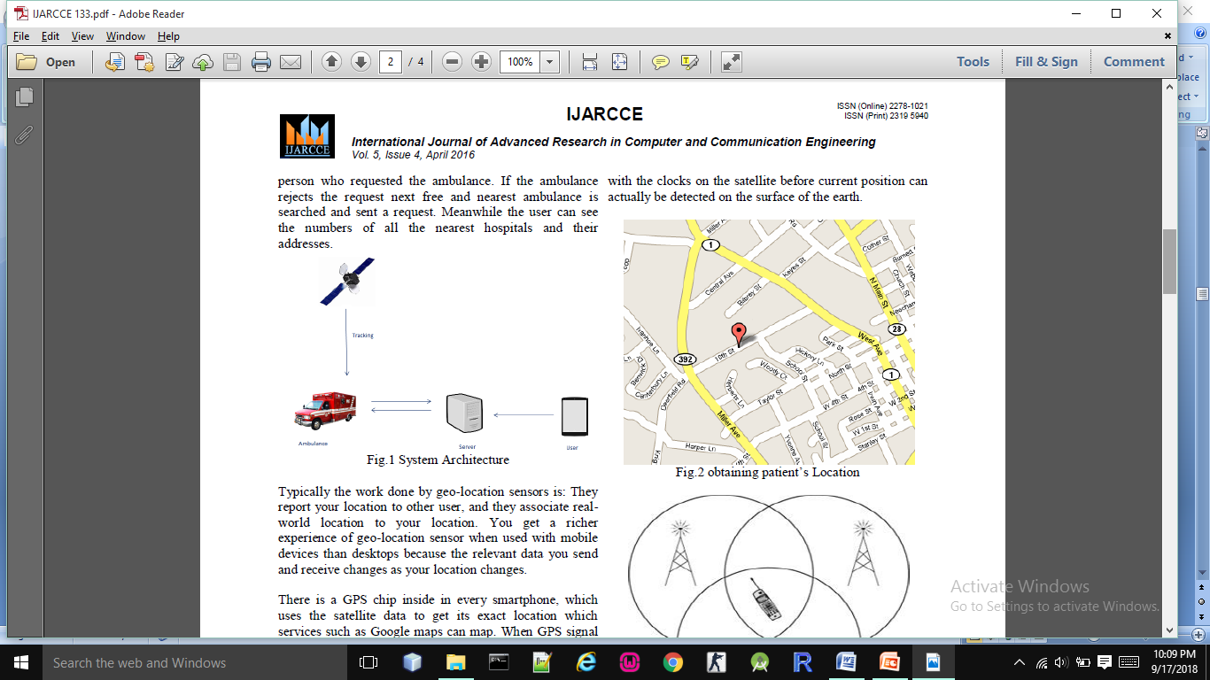

Product Functions
User Application:
User Raise the issue in case of any emergency from his Android Application with description and nature of issue
severity. User’s location tracking is done with the help of GPS is OFF then location tracking is done in Network
mode. All the details of user like Title, Description, Priority and Current location report is send to the server for
further assistance. Server respond location based Emergency Contact Nos to the user application.

Admin Application:
Admin gets notifications n his Android application with Emergency Issues. Admin can also view the person details
and his/her location that has raised the issue. Admin can view the optimal path on Google map with marker to reach
the victim who raised the issue in case of emergency. After resolving the issue, admin can marked the issue as resolved
with certain comments.
Web Based Application for Reporting:
Web Application is useful for generating the reports such as, Area wise issues report, Priority wise issues report, Location wise issues report

<Summarize the major functions the product must perform or must let the user perform. Details will be provided in Section 3, so only a high level summary (such as a bullet list) is needed here. Organize the functions to make them understandable to any reader of the SRS. A picture of the major groups of related requirements and how they relate, such as a top level data flow diagram or object class diagram, is often effective.>

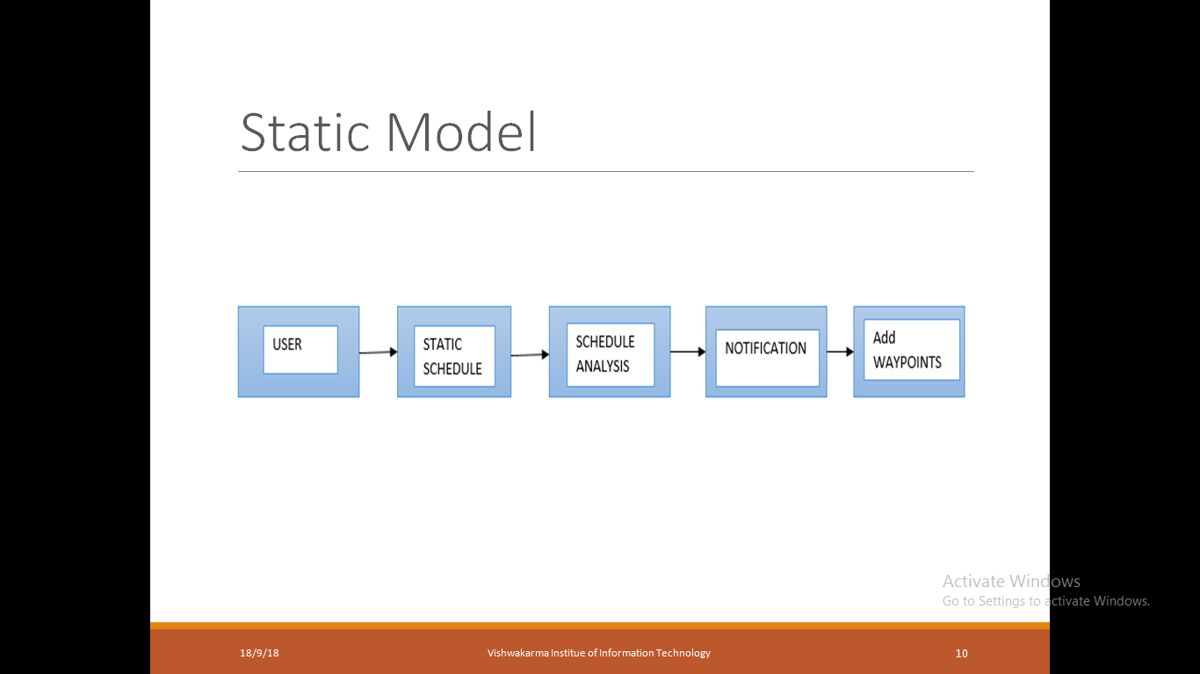

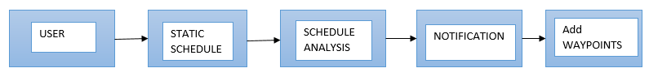
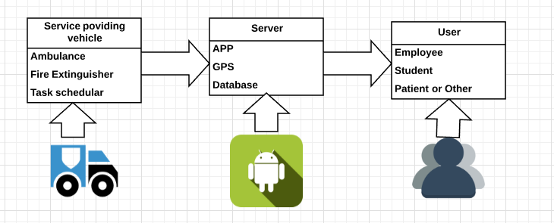

User Classes and Characteristics
<Identify the various user classes that you anticipate will use this product. User classes may be differentiated based on frequency of use, subset of product functions used, technical expertise, security or privilege levels, educational level, or experience. Describe the pertinent characteristics of each user class. Certain requirements may pertain only to certain user classes. Distinguish the most important user classes for this product from those who are less important to satisfy.>

Operating Environment
For now, we are intended at developing a GPS based notification system using android platform only. This is the first version of the system, wherein the system will function only across the app. The system can be accessed from any personal computer(bluestack), mobile phones, laptops (bluestack) having internet connectivity. Also, the system can be supported on any Windows or Linux platforms.

<Describe the environment in which the software will operate, including the hardware platform, operating system and versions, and any other software components or applications with which it must peacefully coexist.>

Design and Implementation Constraints
The system must be connected with the internet all the time. User can only use the application with the help of mobile. This application doesn’t have audio speech recognition technique. We may add it in later version.

<Describe any items or issues that will limit the options available to the developers. These might include: corporate or regulatory policies; hardware limitations (timing requirements, memory requirements); interfaces to other applications; specific technologies, tools, and databases to be used; parallel operations; language requirements; communications protocols; security considerations; design conventions or programming standards (for example, if the customer’s organization will be responsible for maintaining the delivered software).>

User Documentation
There is a user manual attached with the SRS, which states the steps to follow while using the system. Also, the system consists of help menu, which can guide the users online.

<List the user documentation components (such as user manuals, on-line help, and tutorials) that will be delivered along with the software. Identify any known user documentation delivery formats or standards.>

Assumptions and Dependencies
We have, in this document considered that the users dealing with the system can communicate efficiently using the Hindi language.

<List any assumed factors (as opposed to known facts) that could affect the requirements stated in the SRS. These could include third-party or commercial components that you plan to use, issues around the development or operating environment, or constraints. The project could be affected if these assumptions are incorrect, are not shared, or change. Also identify any dependencies the project has on external factors, such as software components that you intend to reuse from another project, unless they are already documented elsewhere (for example, in the vision and scope document or the project plan).>

External Interface Requirements

User Interfaces
The interface for communication between the user and the app is the virtual agent (or the human avatar). This Document only deals with the services.

<Describe the logical characteristics of each interface between the software product and the users. This may include sample screen images, any GUI standards or product family style guides that are to be followed, screen layout constraints, standard buttons and functions (e.g., help) that will appear on every screen, keyboard shortcuts, error message display standards, and so on. Define the software components for which a user interface is needed. Details of the user interface design should be documented in a separate user interface specification.>

Hardware Interfaces
As mentioned above, for now the communication medium is the text communication. If the scope is extended to include the audio, video and image inputs, then hardware interfaces like audio receiver, cameras, etc. can be used.

<Describe the logical and physical characteristics of each interface between the software product and the hardware components of the system. This may include the supported device types, the nature of the data and control interactions between the software and the hardware, and communication protocols to be used.>

Software Interfaces
The entire system will be built on the android, using the SDK toolkit, android libraries and functionalities. The targeted language for communication here will be mainly the English language .

<Describe the connections between this product and other specific software components (name and version), including databases, operating systems, tools, libraries, and integrated commercial components. Identify the data items or messages coming into the system and going out and describe the purpose of each. Describe the services needed and the nature of communications. Refer to documents that describe detailed application programming interface protocols. Identify data that will be shared across software components. If the data sharing mechanism must be implemented in a specific way (for example, use of a global data area in a multitasking operating system), specify this as an implementation constraint.>

Communications Interfaces
The system will be running on the web platform using the android. Sessions will be created for each chat instance for each user.

<Describe the requirements associated with any communications functions required by this product, including e-mail, web browser, network server communications protocols, electronic forms, and so on. Define any pertinent message formatting. Identify any communication standards that will be used, such as FTP or HTTP. Specify any communication security or encryption issues, data transfer rates, and synchronization mechanisms.>

System Features
<This template illustrates organizing the functional requirements for the product by system features, the major services provided by the product. You may prefer to organize this section by use case, mode of operation, user class, object class, functional hierarchy, or combinations of these, whatever makes the most logical sense for your product.>

Login (User/Admin)
Android Application with description and nature of issue
severity. User’s location tracking is done with the help of
GPS is OFF then location tracking is done in Network
mode. All the details of user like Title, Description,
Priority and Current location report is send to the server for
further assistance. Server respond location based
Emergency Contact Nos to the user application.
<Don’t really say “System Feature 1.” State the feature name in just a few words.>

Description and Priority
This feature is used by the User/Admin to login into system. They are required to enter username and password they selected at the time of registration. The username and password will be verified and if it is valid then user/admin is allowed to access the system.

<Provide a short description of the feature and indicate whether it is of High, Medium, or Low priority. You could also include specific priority component ratings, such as benefit, penalty, cost, and risk (each rated on a relative scale from a low of 1 to a high of 9).>

Stimulus/Response Sequences
- While registration, user has to enter some basic personal details and then he/she can select a username and password.
- User can login into system with valid username and password, selected by user at the time of registration.
- After successful login, System provides system features to user.
- Admin login details will be set initially.
<List the sequences of user actions and system responses that stimulate the behavior defined for this feature. These will correspond to the dialog elements associated with use cases.>

Functional requirements

- Receiving Incident information from the user.
- Locating nearest ambulance.
- Finding the Best route to the incident
- Displaying timing information and error reporting.
- Tracking and monitoring of ambulance.
- Selection of best path based on fuel efficiency.
Technical requirements
- System is based on android platform and minimum requirement is android version 5.0 user should have internet connection and access of GPS Service.
- We are using firebase server for manipulating real time data.
- We are fetching live traffic data from google map api and store on server for analysing purpose.
- We are using java language for development purpose and using mysql database and php for server side scripting.
- Application shows user friendly maps for routing purpose.

Remedies

Description of Feature
If user in conversation with system, specifies that he/she is not feeling well or going through some pain then System will communicate with the user and will try to get more information about the symptoms and will figure out which disease user is suffering from. System will also provide some homemade remedies. System will keep track of user symptoms daily to figure out the seriousness of illness.

Response Sequence
- User specifies some symptoms he/she is suffering from.
- System will try and get more information about symptoms from user like number of days user is suffering, etc.
- System will give some homemade remedies to the user and will keep track of the user symptoms.
- After some days, if the user is still suffering from the same symptoms then system will advise user to visit a doctor.

Functional Requirements
- User should specify proper information about his/her symptoms.
- System will match this information with the data in its database.
- System will retrieve all the information related to the user symptoms and will provide it to the user.
- System will keep track of the user symptoms in the database and will advise accordingly.

Smart Communication

Description of Feature
If the user just wants to chat normally with the system then system will act as a virtual friend for the user and will provide suitable response to the user based on the user conversation.

Response Sequence
- User chats normally with the system.
- System figures out a suitable response for the user based on the user input.

Functional Requirements
- User starts conversation with system other than related to health then
- System gets the suitable response from its database.
- System adapts to the user conversation.
- System stores the chat with user and provides response based on both the chat history and the data stored in its database.

Reminder

Description of feature
If the user gives information to the system about his/her medication and the days for which he/she needs to take medicines and the time at which the medicines are to be taken and also for the number of medicines he/she has purchased then the system will provide timely reminders to the user according to the information specified by the user.

Response of sequence
- User informs the system about his/her medications.
- System tries to get more and more information about user's medicines and stores this information in its database.
- System gives timely reminders to the user like 'it's time to take your medicines', 'you need to purchase more medicines ‘, etc.

Functional Requirements
- If the user informs the system about his/her medicines then system store this information in its database.
- System should calculate the time at which user should be reminded about the medication and also what type of reminder should be given to user store this calculation in database.
- System should give reminders based on the information stored in database.

Other Nonfunctional Requirements

Performance Requirements
The responses generated by the system should be instant enough so that the user does not get bored. The user must feel that he/she is having a conversation with a human itself. The speed, accuracy and relevance of the messages delivered by the system will prove the efficiency of the software.

<If there are performance requirements for the product under various circumstances, state them here and explain their rationale, to help the developers understand the intent and make suitable design choices. Specify the timing relationships for real time systems. Make such requirements as specific as possible. You may need to state performance requirements for individual functional requirements or features.>

Safety Requirements
Safety here deals with the remedies provided by the system to the user according to his symptoms. Care should be taken to provide appropriate medication.

<Specify those requirements that are concerned with possible loss, damage, or harm that could result from the use of the product. Define any safeguards or actions that must be taken, as well as actions that must be prevented. Refer to any external policies or regulations that state safety issues that affect the product’s design or use. Define any safety certifications that must be satisfied.>

Security Requirements
Security of the system deals with the user name and password information of the users and also the chat that the user had had with the system. The chat should be preserved with the system only and should not be open to the public.

<Specify any requirements regarding security or privacy issues surrounding use of the product or protection of the data used or created by the product. Define any user identity authentication requirements. Refer to any external policies or regulations containing security issues that affect the product. Define any security or privacy certifications that must be satisfied.>

Software Quality Attributes
It is necessary to test the system at every stage to assure its speed and accuracy of the replies provided. This would approve good quality of the software delivered.

<Specify any additional quality characteristics for the product that will be important to either the customers or the developers. Some to consider are: adaptability, availability, correctness, flexibility, interoperability, maintainability, portability, reliability, reusability, robustness, testability, and usability. Write these to be specific, quantitative, and verifiable when possible. At the least, clarify the relative preferences for various attributes, such as ease of use over ease of learning.>

Business Rules
<List any operating principles about the product, such as which individuals or roles can perform which functions under specific circumstances. These are not functional requirements in themselves, but they may imply certain functional requirements to enforce the rules.>

Other Requirements
<Define any other requirements not covered elsewhere in the SRS. This might include database requirements, internationalization requirements, legal requirements, reuse objectives for the project, and so on. Add any new sections that are pertinent to the project.>
Appendix A: Glossary
- Tokenization: Given a character sequence and a defined document unit, tokenization is the task of chopping it up into pieces, called tokens.
- Part-of-speech tagging (POS Tagger): In corpus linguistics, part-of-speech tagging, also called grammatical tagging or word-category disambiguation, is the process of marking up a word in a text (corpus) as corresponding to a particular part of speech, based on both its definition and its context i.e., its relationship with adjacent and related words in a phrase, sentence, or paragraph. A simplified form of this is commonly taught to school-age children, in the identification of words as nouns, verbs, adjectives, adverbs, etc.
- Entity: entity is a real-world object, such as persons, locations, organizations, products, etc., that can be denoted with a proper name.
- Dependency parser: A dependency parser analyses the grammatical structure of a sentence, establishing relationships between head and words which modify those heads.
- Co-reference Resolution: Coreference resolution is the task of finding all expressions that refer to the same entity in a text.
- Web Crawler: A Web crawler, sometimes called a spider, is an Internet bot that systematically browses the World Wide Web, typically for the purpose of Web indexing (web spidering).

<Define all the terms necessary to properly interpret the SRS, including acronyms and abbreviations. You may wish to build a separate glossary that spans multiple projects or the entire organization, and just include terms specific to a single project in each SRS.>
Appendix B: Analysis Models
<Optionally, include any pertinent analysis models, such as data flow diagrams, class diagrams, state-transition diagrams, or entity-relationship diagrams.>
Appendix C: To Be Determined List
<Collect a numbered list of the TBD (to be determined) references that remain in the SRS so they can be tracked to closure.>

